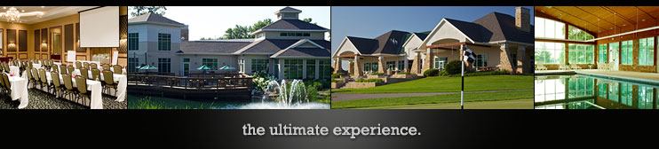

**2024 Men’s League Opportunities at Swan Lake Resort**

**Monday Night Men’s League at Swan Lake Resort**

This fun, low cost 9-hole, 2 Man League will play on Monday evenings teeing off between 4:30 pm and 5:30 pm. Play will alternate between all nines of the Black and Silver Courses. The league is open to all players. We will help you establish a league handicap.

**League Details**

* The League Season will be 21 weeks from 4-15-24 through 9-16-24. Season Ending Outing on 9-30-24 at a 1:30pm Shotgun. Introductory Meeting on 4-1-24 at 5:30pm in Grill at the Clubhouse
* 2 players will comprise each team. Weekly your 2 man team will play an opposing team where there will be 2 individual matches and a team match going on.
* Each Individual match is worth 2 pts/hole with an additional bonus 2 pts for the player in each match with the most pts won over the 9 holes. The team match is also worth 2 pts/hole plus the 2 bonus pts. The league payouts are done in 2 halves of the league and based on the team total pts over each half

**League Fees**

* League Dues are $76 per player and used to build the prize fund for credit payout
* Weekly Swan Lake Green Fee is $24 to ride, $15 to walk
* Keep in mind our Twilight Membership is only $525 for the year and is a great option for League players!

**Please Sign Up by:** calling Chad Hutsell, Director of Golf and League Chairman at 574-780-2693, or by emailing Chad at [chutsell@swanlakeresort.com](mailto:chutsell@swanlakeresort.com)

**Thursday Night Men’s League at Swan Lake Resort**

This fun, low cost 9-hole, 2 Man League will play on Thursday evenings teeing off between 4:30 pm and 5:30 pm. Play will alternate between all nines of the Black and Silver Courses. The league is open to all players. We will help you establish a league handicap.

**League Details**

* The League Season will be 23 weeks from 4-4-24 through 9-12-24. Season Ending Outing on 9-15-24 at a 1:30pm Shotgun. Introductory Meeting on 3-28-24 at 6pm in the Grill at the Golf Clubhouse.
* Each week, each team can earn a maximum of 60 points for two individual matches and a team match. Individual matches are based on the lowest 1 Net Best Ball Score between individuals and team matches are based on the lowest combined two man total with handicap between the teams
* Individual matches are worth 2 pts/hole with an additional 2 pts for the match winner. The team match is worth 2 pts/hole and 2 pts for the team match winner
* Weekly Individual Awards: Individual Low Gross and Low Net for Golf Shop Credit and skins for cash

**League Fees**

* League Dues are $80 per player and used to build the prize fund for credit payout
* Weekly Swan Lake Green Fee is $24 to ride, $15 to walk

**Please Sign Up by:** calling Ryan Steele, Head Golf Professional and League Chairman in the Golf Shop at 574-936-9798 or by emailing Ryan at [rsteele@swanlakeresort.com](mailto:rsteele@swanlakeresort.com)