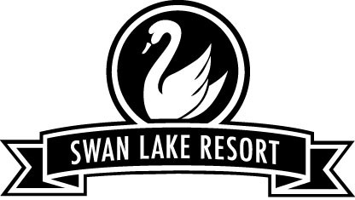
Golf Speed Training
Learn to swing your clubs faster NOT harder.

What: A 12-week course that will improve each players swing speed by developing proper sequencing, improving tone and flexibility in key muscle groups to give you more distance with all your clubs.
Includes: slow motion swing analysis, Flightscope radar data, flexibility and strength screening and 12 group sessions. Custom drills and exercise video.

*Not a beginners course*

When: Day Time
Fridays 10 – 11 am Or 4 – 5pm

Dates
January 6, 13, 20, 27
February 3, 10, 17, 24
March 3, 10, 17, 24

Where: The Academy building

Cost: $120 p/p

Sign-up: Call John Ericsson, Director of Instruction, 574-935-5680 ext. 722 or email jericsson@swanlakeresort.com

Be the Top Gun in your foursome.
“I feel the need for SPEED!”

